What data can we collect from the oilfield?

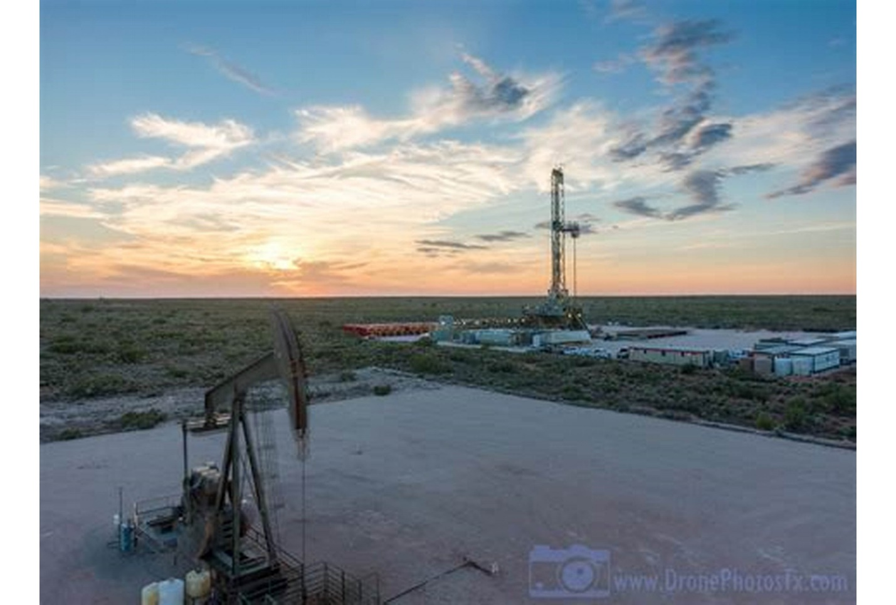

1. Machine temperature.
2. Machine speed.
3. Machine running time.
4. Control (on, off).

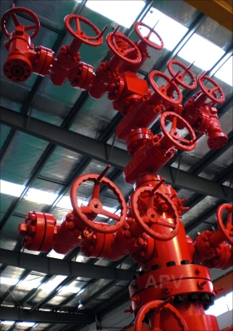

1. Oil pressure.
2. Oil temperature.
3. Control (on, off).
4. Detect the leak in the tube.

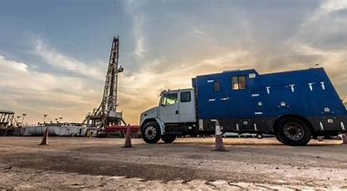

1. Car speed.
2. Car location.
3. Car engine temperature.
4. Car fuel percentage.

And more dependent on the type of machine itself

Secure data

1. Secure devices
   1. Certificates.
   2. Identity (unique id).
   3. Secure ssid and password.
   4. Update firmware.
   5. classify devices.
2. Secure applications
   1. Use complex passwords, patterns, and PINs.
   2. Set up two-factor authentication.
   3. Token.
   4. Login from one device.
3. Secure connections
   1. Encrypt data.
   2. Quality of service.
   3. Notifications for disconnections devices.